1. Install Docker, either on your native OS or on a VM. Make sure it runs. Type "docker -v" to check if it's installed

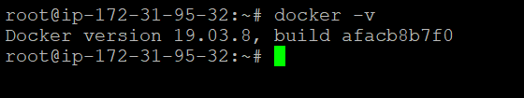

1. Find a image from dockerhub of your choice(recommeded: nginx), don't use browser, pull the official image from dockerhub

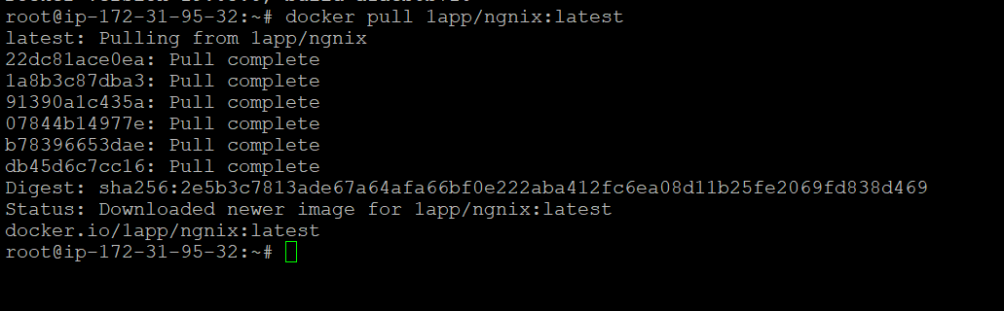

1. List all the available images in your machine/vm, make sure you see recently pulled image in the list

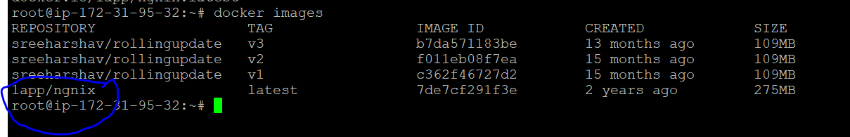

1. Find out the "Full" ImageId of the image that you pulled and write it below

7de7cf291f3e

1. Create a container of your image



1. List all the running containers



1. List all the running and stopped containers.

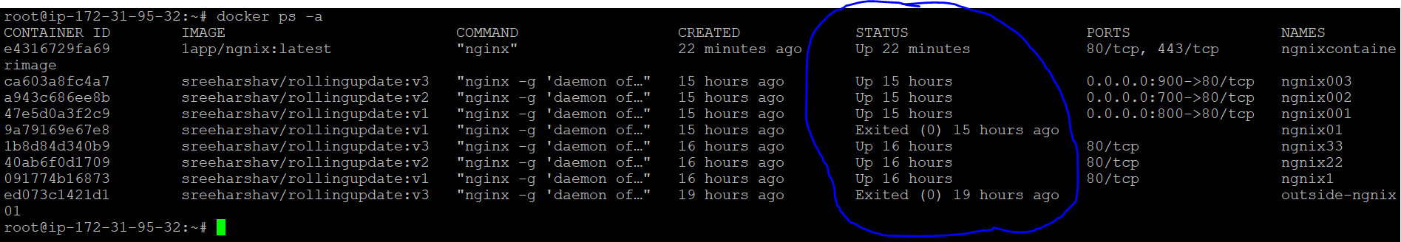

1. Find out the "Full" containerId of the container and write it below.

e4316729fa69

9.Find out how many image layers are used to build this image.

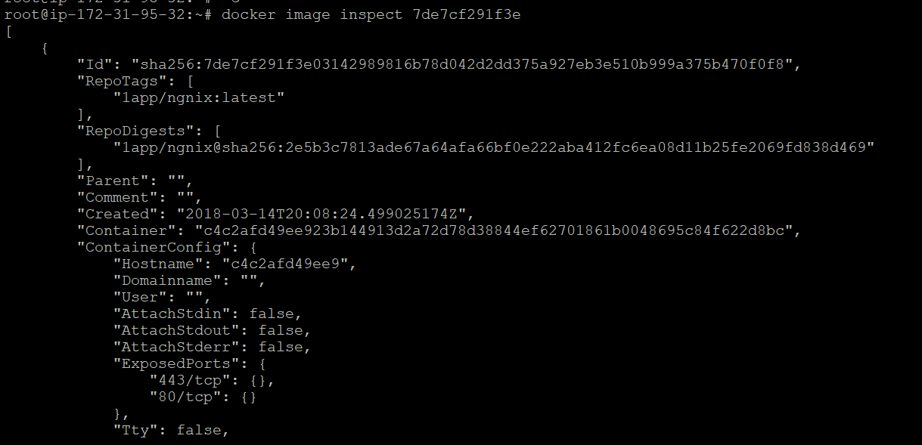

10. Get the Apache Tomcat 7 server image from the docker hub

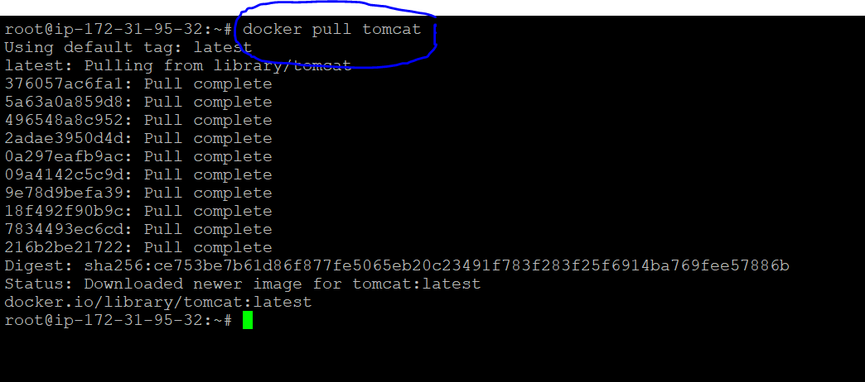

11. Run the Apache Tomcat 7, I mean create a container of Apache Tomcat



12. Find out what is the IP Address of the Apache Tomcat Container that it is running on

#docker inspect container id.

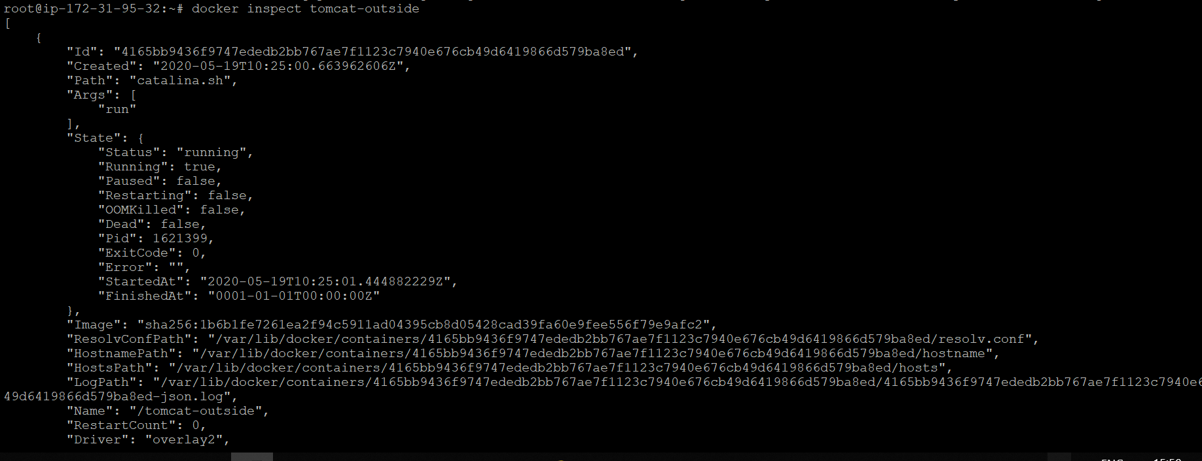

13.Which Port it is using?

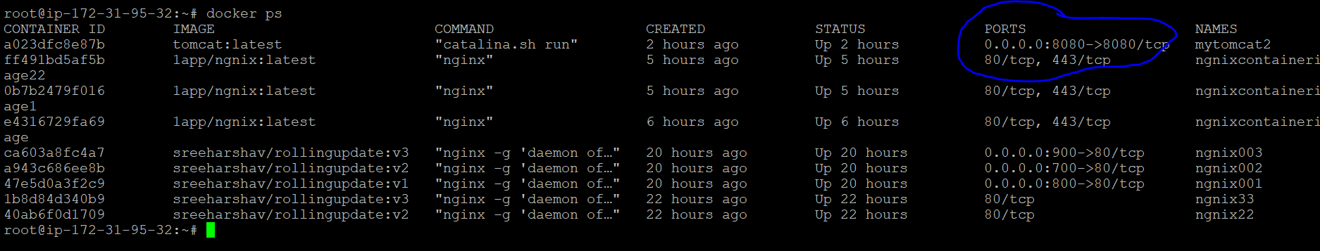

14. Try to access the Tomcat's home page from your machine/vm.

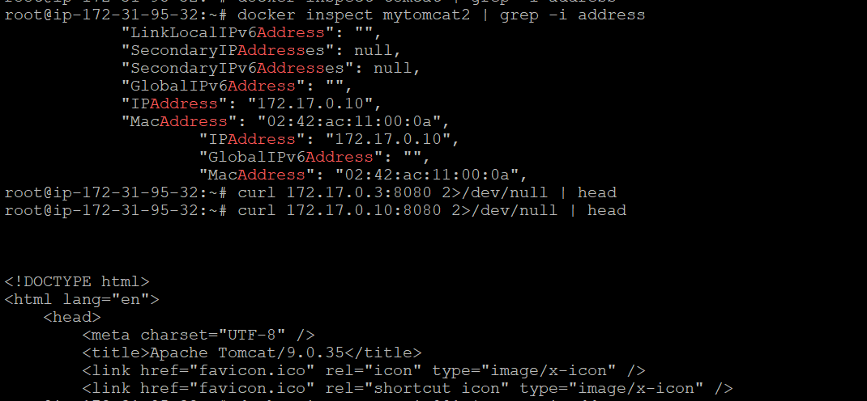

15. What is the disk size of Apache Tomcat image?

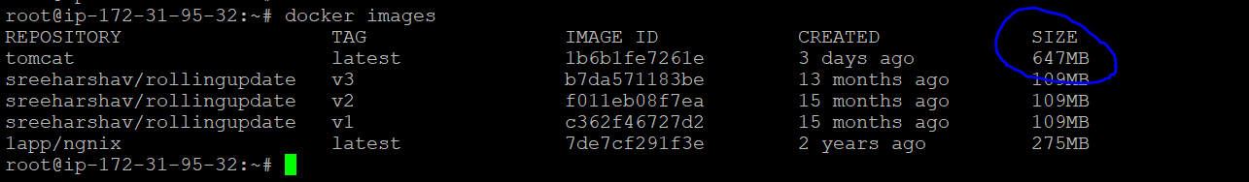

17. Find out which port is exposed for tomcat?

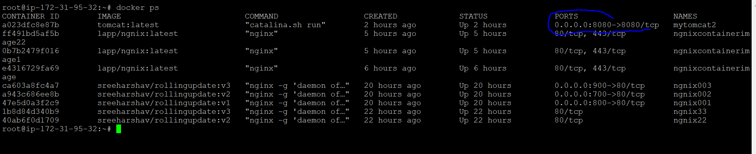

19. Pull ubuntu os from dockerhub, try to pull 2 images of ubuntu, Except the latest one.

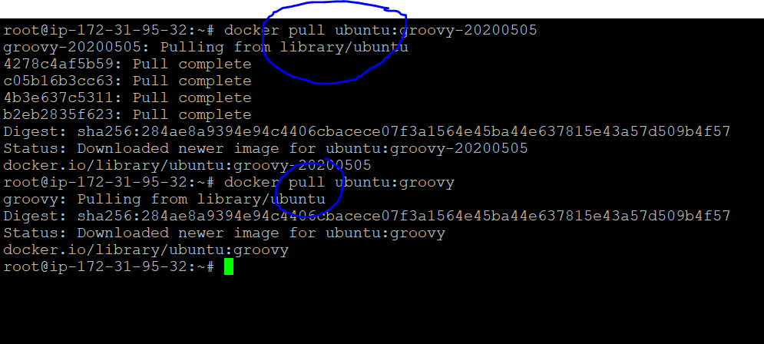

20. Run the container of ubuntu in attached mode

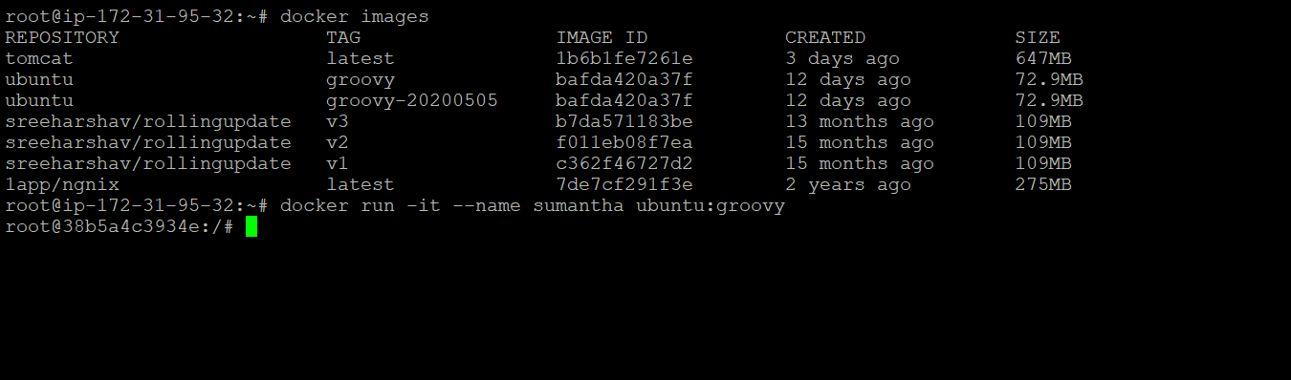

21. Run the container of another ubuntu in detached mode.

